Penetration Testing Report

Mediroza General Hospital
Target: https://medirozahospital.com
Engagement Type: Black-box Penetration Test
Batch: B082 | Week 4
NAME | NICHOLAS KIPTOO
WEEK TASK | 4
ORGANIZATION | NETWORKWALKS
CLASSIFICATION | CONFIDENTIAL

Networkwalks internship for cybersecurity and ethical hacking

THIS REPORT CONTAIN CONFIDENTIAL INFORMATION FROM MEDIROZA HOSPITAL. CONDUCTED UNDER WRITTEN PERMISSION FROM MEDIROZA THROUGH NETWORKWALKS. DO NOT USE THE KNOWLEDGE TO GAIN UNATHORISED ACCESS TO OTHER SYSTEM WITHOUT WRITTEN PERMISSION . Cybercrimes Act, 2018 (Cap. 79C). It was amended in 2025-(kenya)

- Executive Summary
A penetration test was conducted to identify security weaknesses in a controlled computer environment. The assessment involved reconnaissance, network scanning, service enumeration, vulnerability identification, and controlled validation of selected findings. The objective was to determine whether an attacker could identify and exploit weaknesses and to provide recommendations for improving the security of the tested environment.
Overall Risk Rating: Medium
2. SCOPE OF THE ASSESSMENT
The following systems were included in the assessment:
Item Details
Target medirozahospital.com
Target IP 199.188.201.16
Testing environment Authorized laboratory
Tester nicholas kiptoo C|EH
Date 6-9-2026
Tools Nmap, WhatWeb, HYDRA, Burp Suite, Wireshark,xhydra
Methodology Reconnaissance → Scanning → Enumeration → Vulnerability Assessment → Validation → Reporting
3.OBJECTIVES
The objectives were to:
- -Identify active ports and exposed services.
- -Determine open ports and running services.
- -Identify potential vulnerabilities.
- -Assess the security configuration of the target.
- -Validate selected vulnérabilités safely.
- -Recommend appropriate remediation measures.

- SCOPE AND METHODOLOGY
The first thing in penetration testing and ethical hacking is footprinting and reconnaissance. Several tools are used here to get more details that will help for next step. It so crucial that when one thing misses it will be difficult to succeed. i run whatweb in terminal to get ip address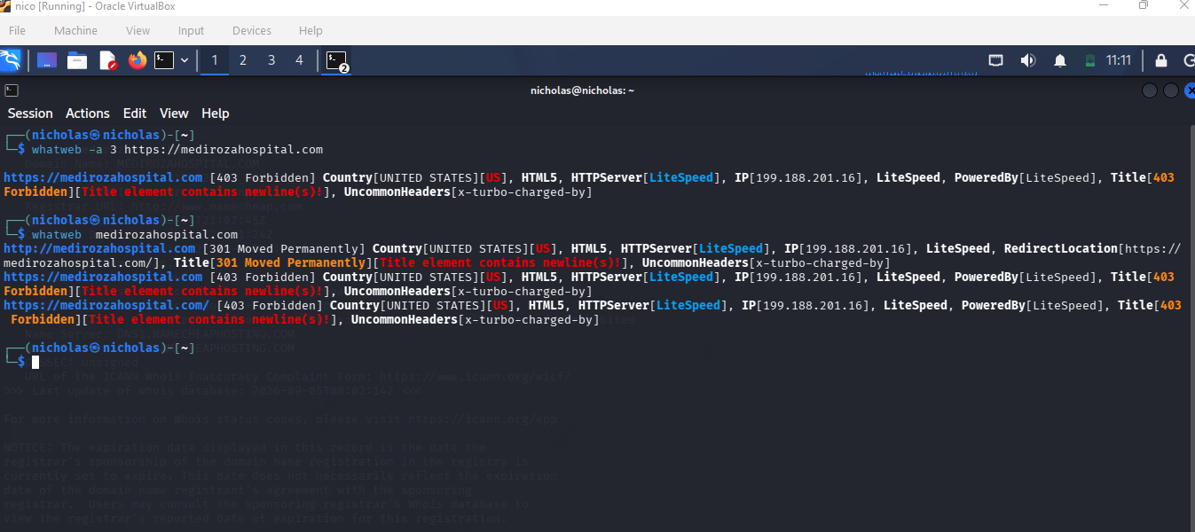
After get ip address, run nmap to look for open ports and service it runs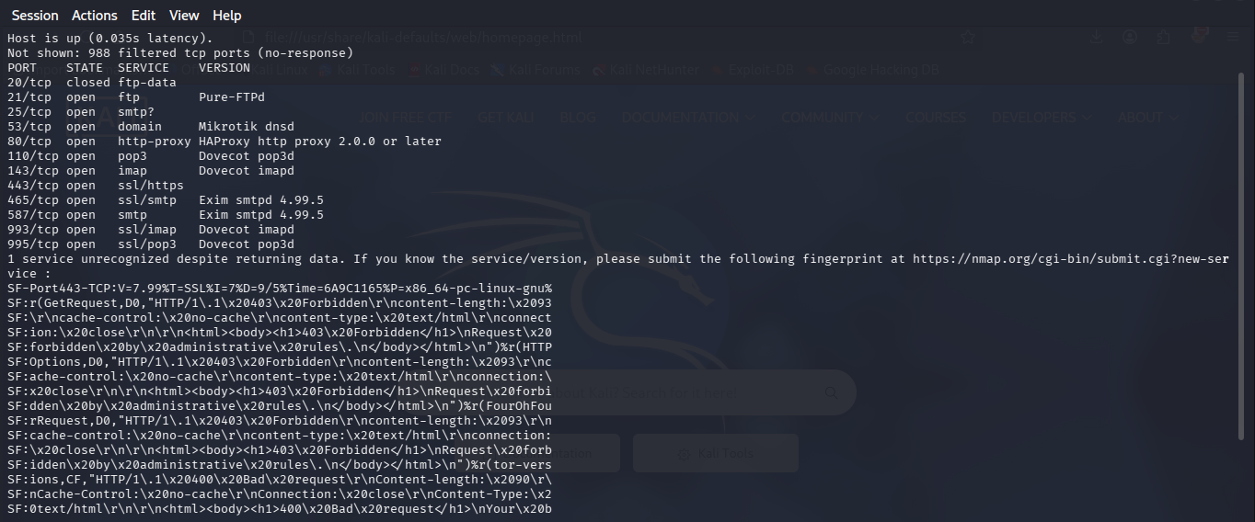
Do brute force attack using hydra. Since some useful port like ftp is open. But will be limited if firewall is in placed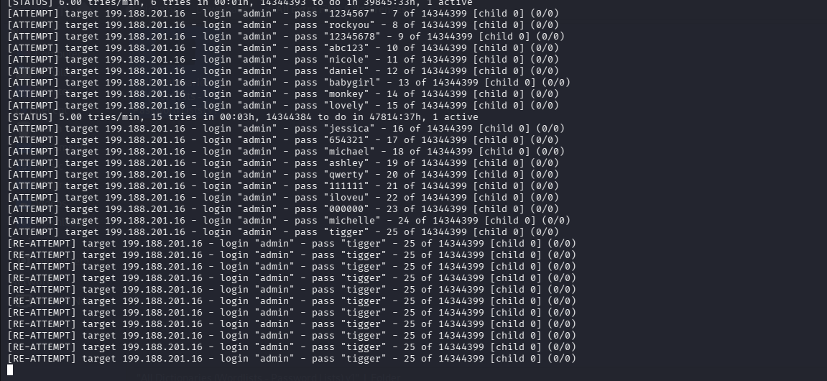
Use xhydra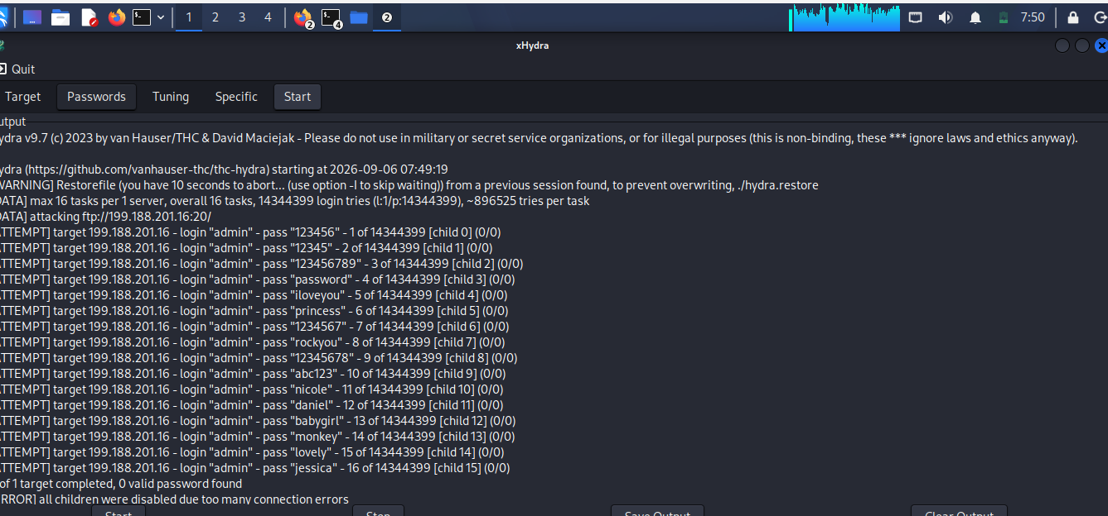
Children were disabled because it has firewall. We have to try another way to get in. The patient portal login at /patient/login.php was first tested for SQL injection on the username/password fields; this
did not succeed. The login form was then tested using Burp Suite Intruder against the username admin, cycling through
a common password wordlist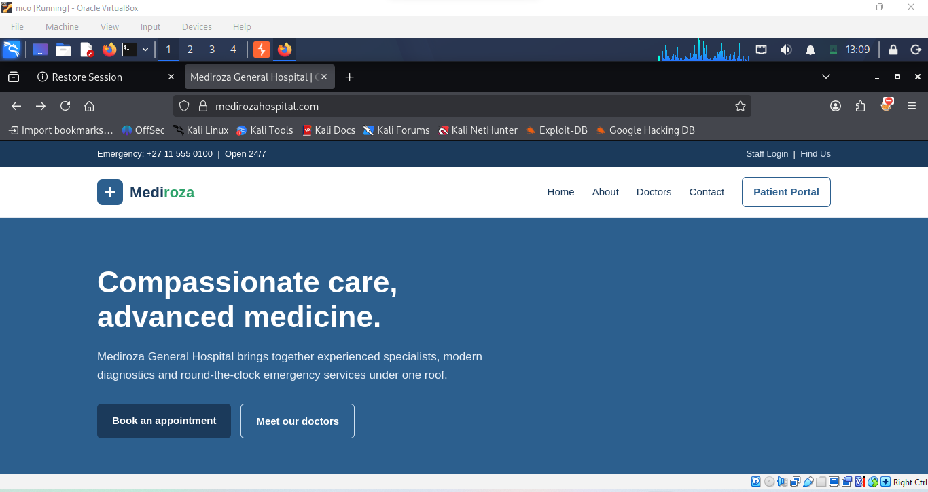
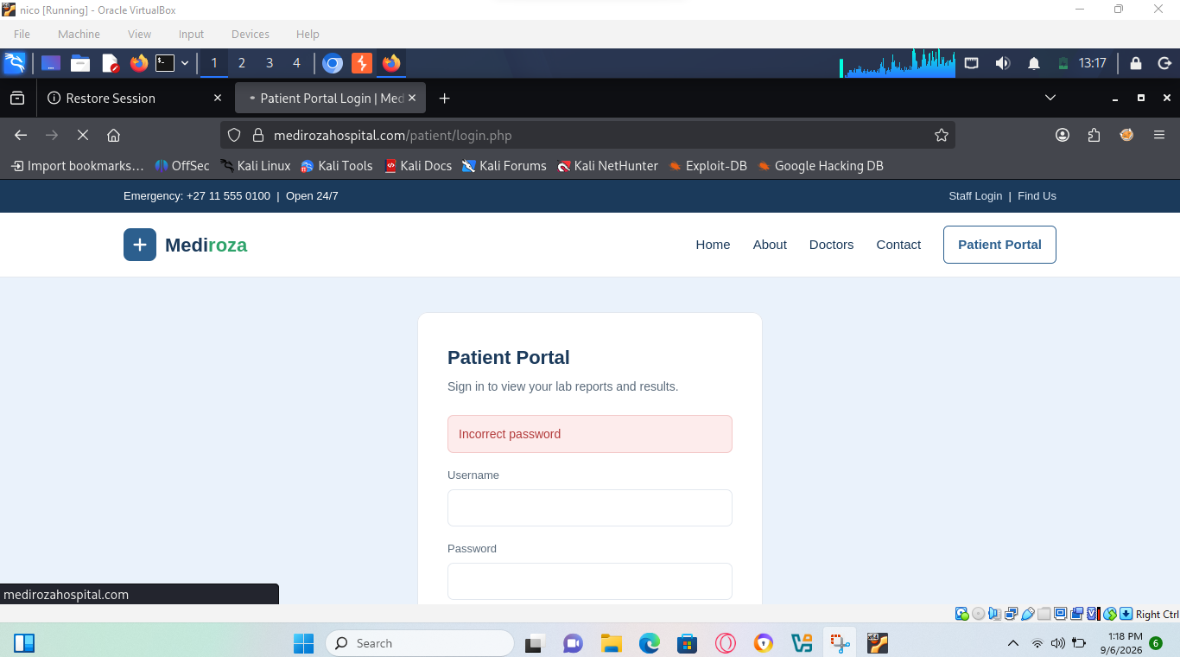
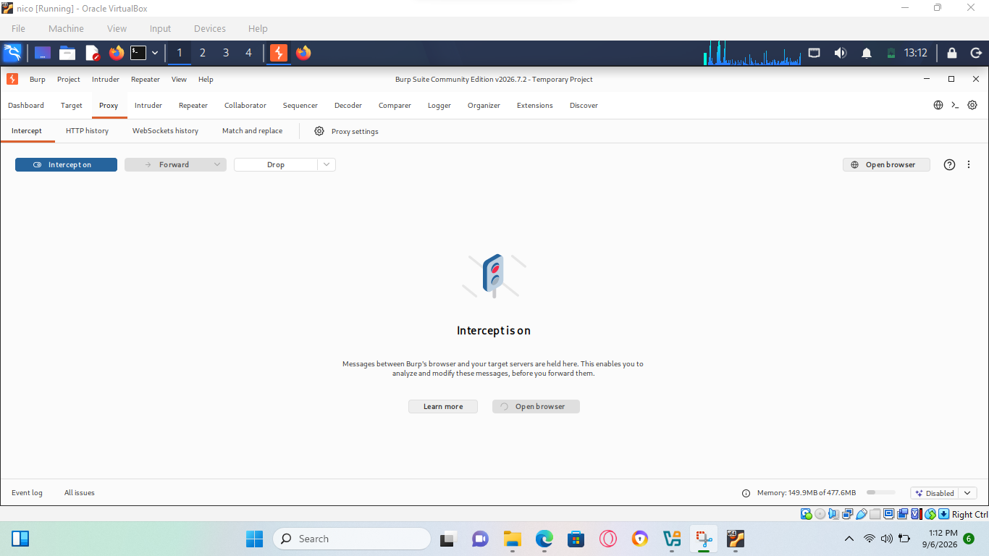

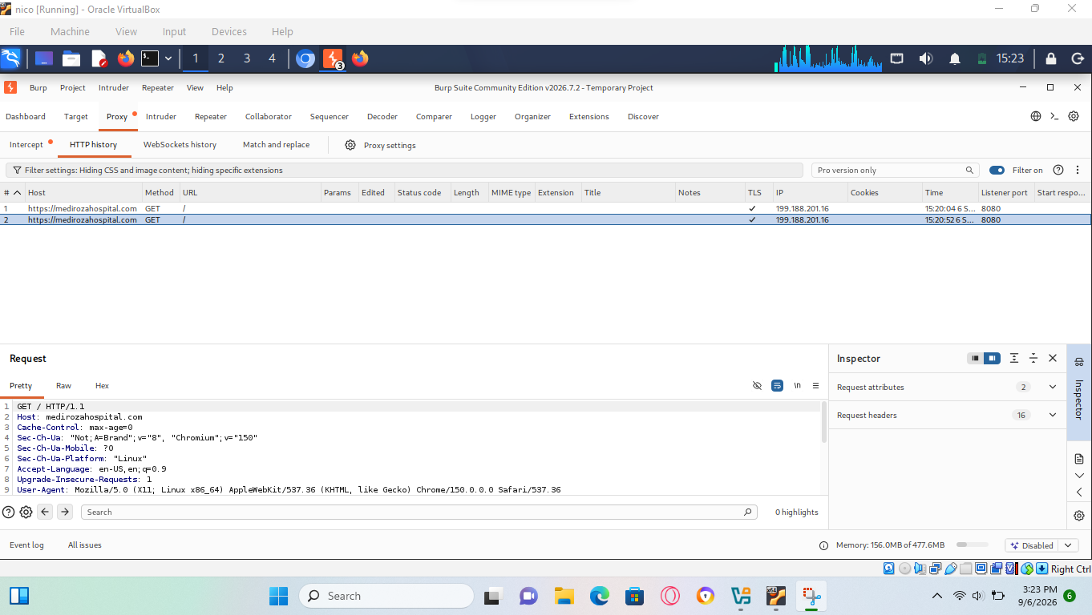
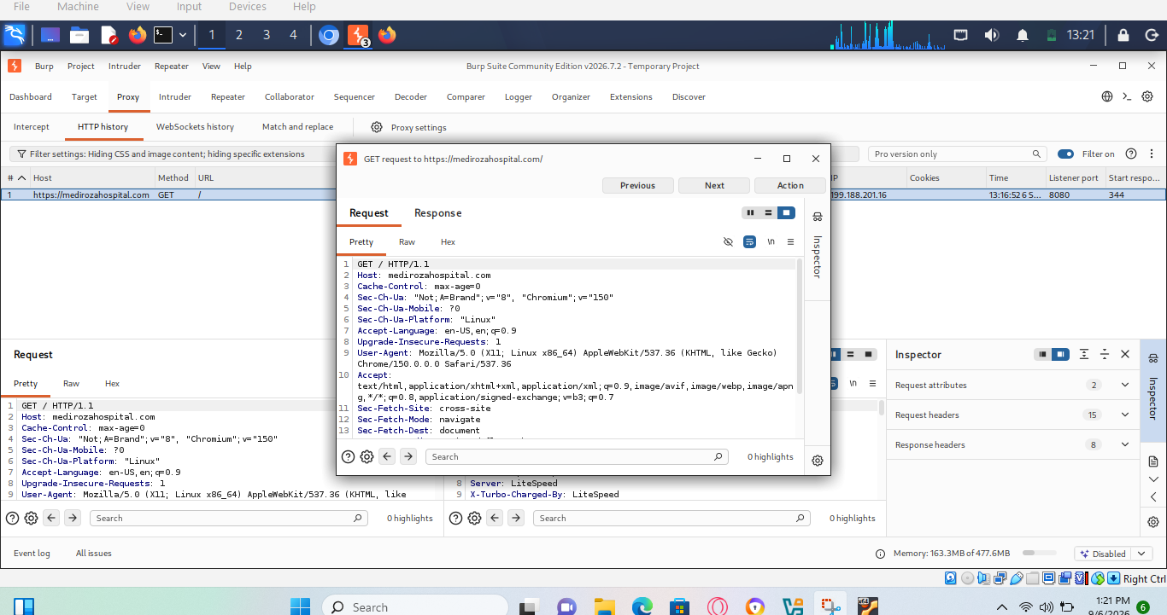
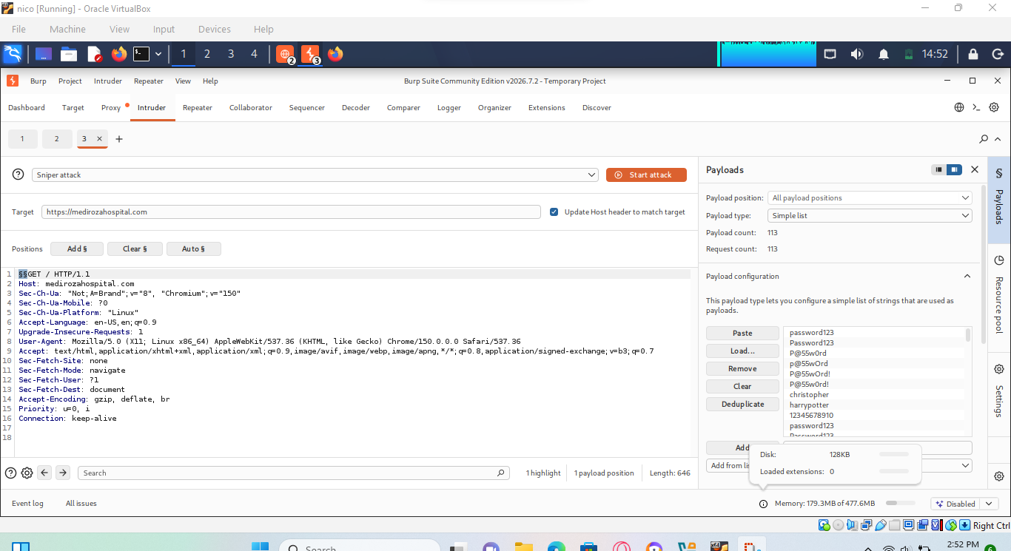
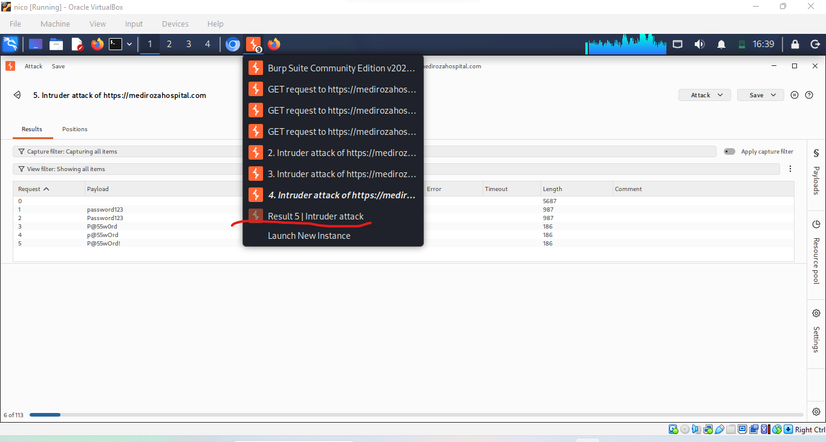
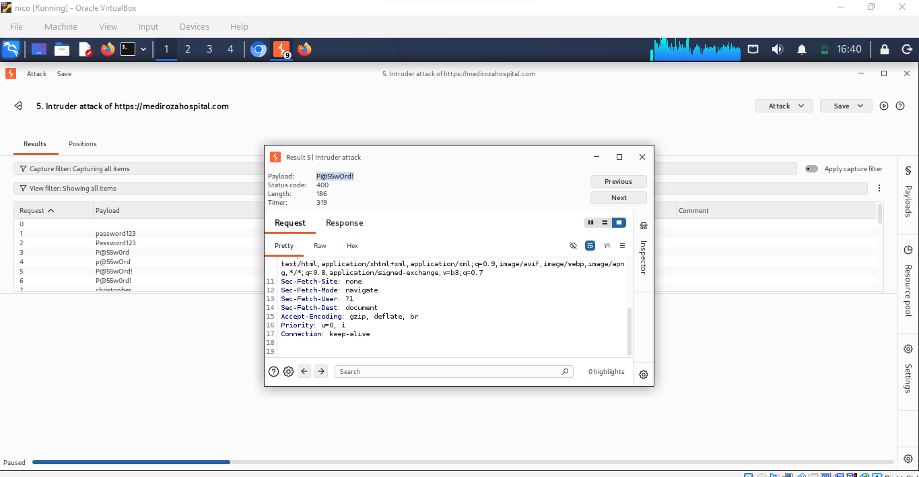
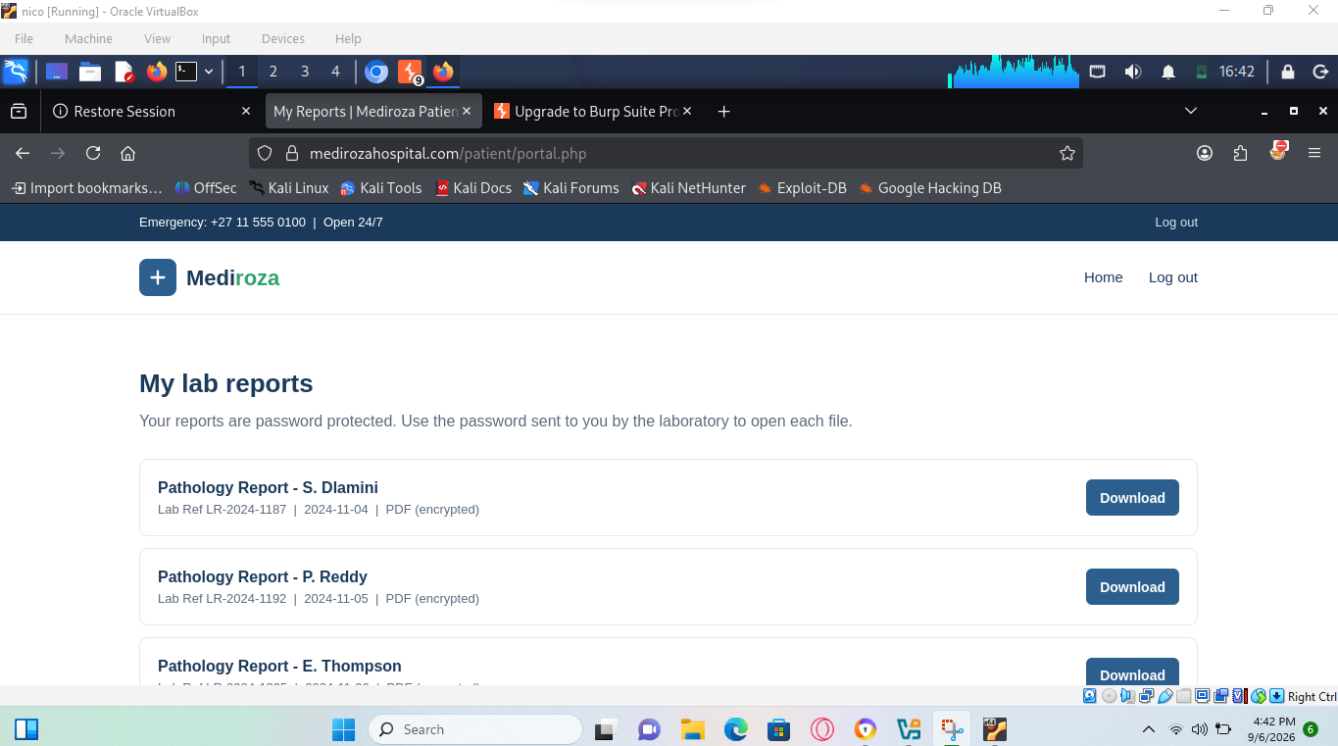

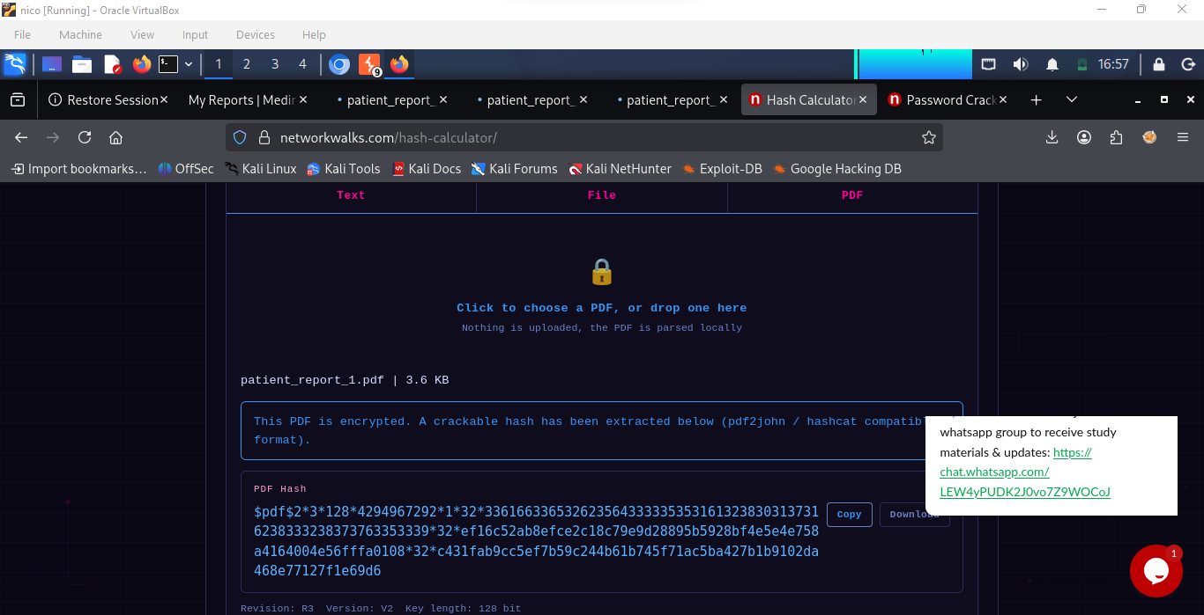
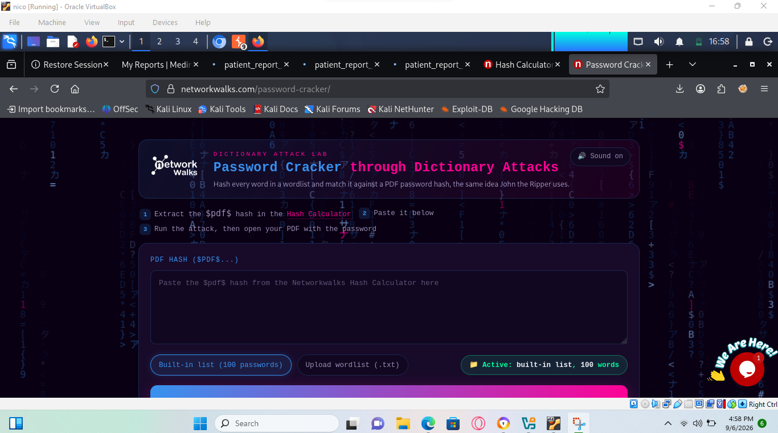
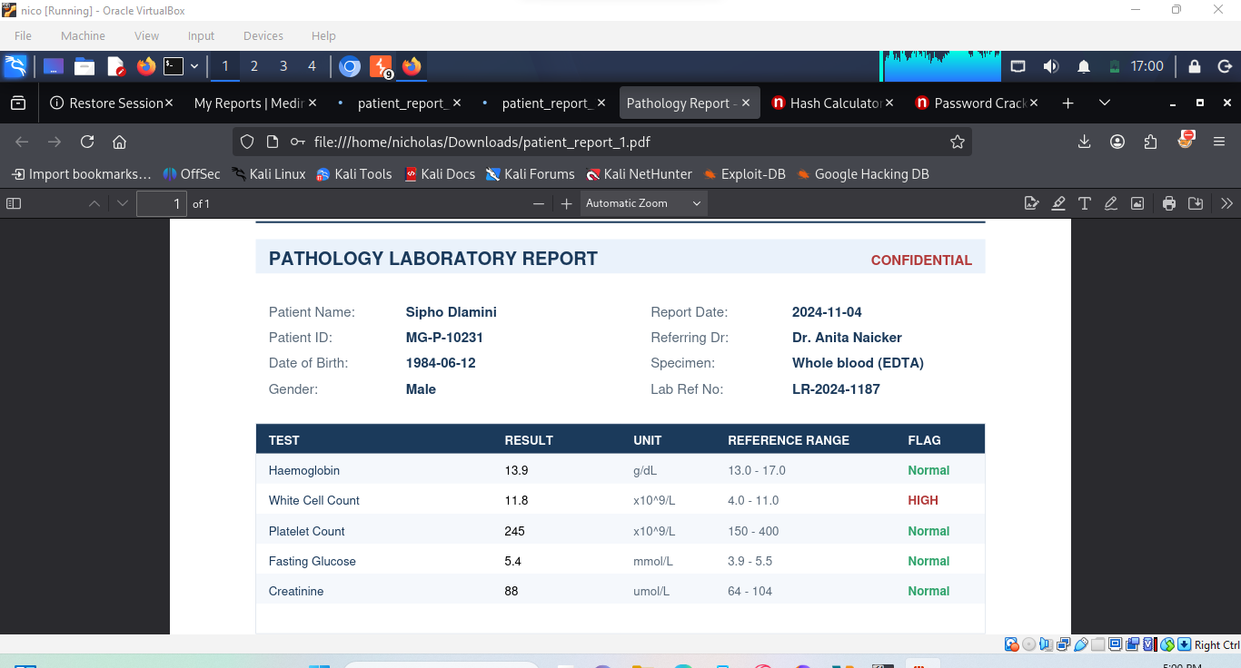
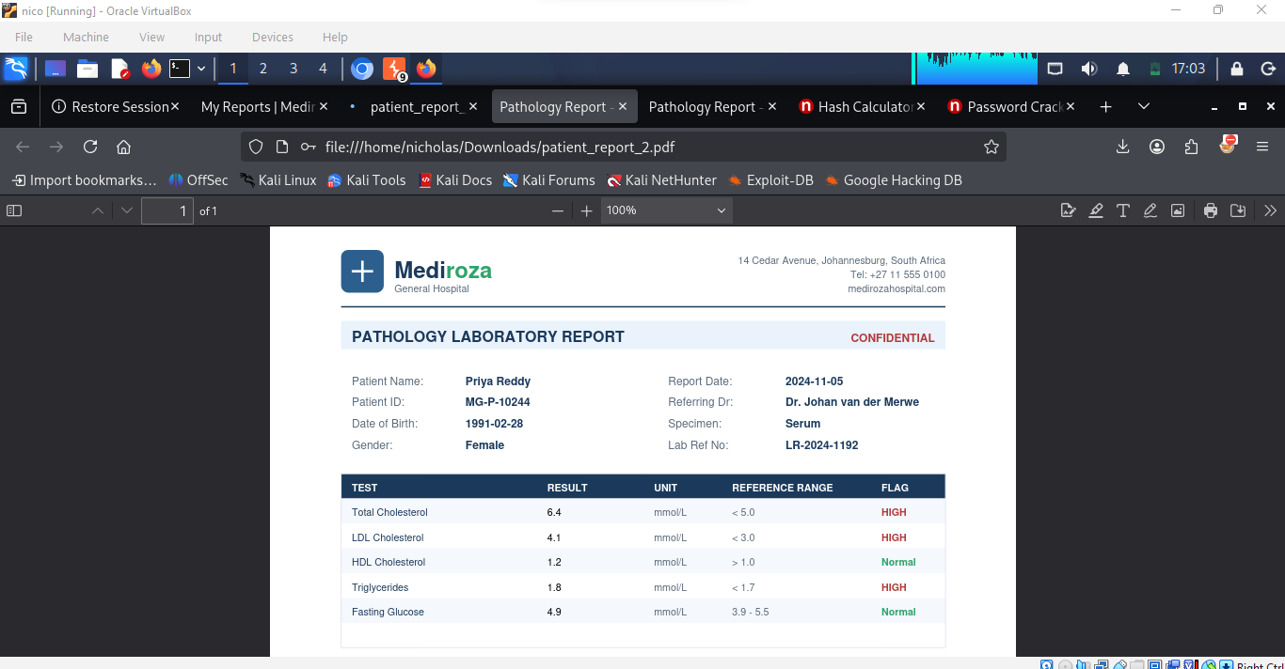
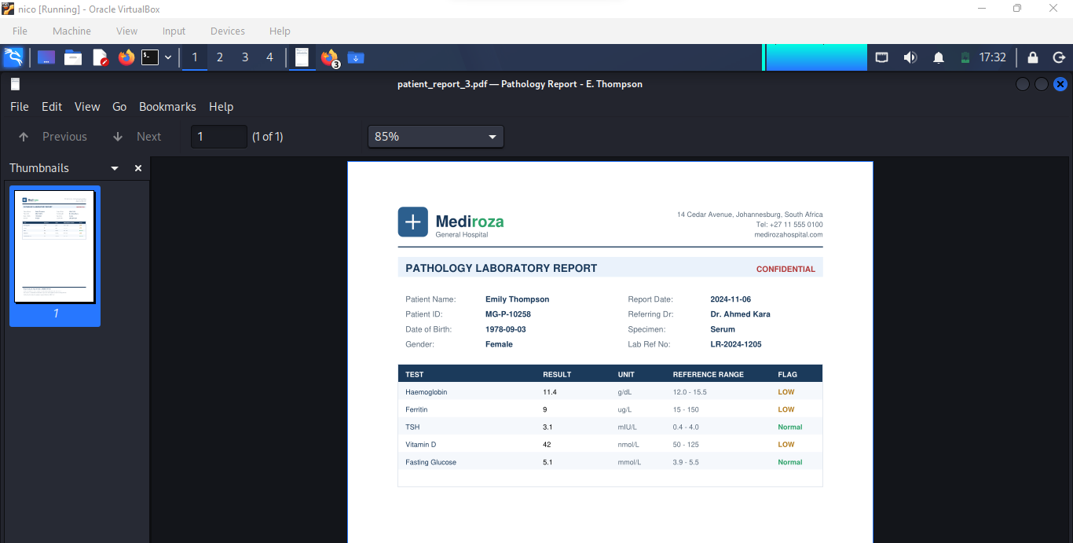
- RISK RATINGS AND FINDINGS
(for mediroza and other website of the same)
- Weak passwords and authentication – no MFA, predictable passwords, or poor login protections.
- SQL injection vulnerabilities – user input is inserted into database queries without proper parameterization.
- Cross-Site Scripting (XSS) – the site accepts and displays untrusted input without proper output encoding.
- Broken access control – users can access another user's information or functions they shouldn't have access to.
- Outdated software – old CMS, plugins, libraries, or server software with known vulnerabilities.
- Insecure file uploads – allowing dangerous or unexpected files to be uploaded without proper validation.
- Poor session management – insecure cookies, long-lived sessions, or failure to invalidate sessions after logout.
- Exposed sensitive information – passwords, API keys, database credentials, or configuration files accidentally accessible.
- Security misconfiguration – unnecessary services, default credentials, directory listing, verbose error messages, etc.
- Missing HTTPS or poor TLS configuration – allowing sensitive information to travel insecurely.
- Lack of rate limiting – login and other sensitive endpoints can be repeatedly attempted without adequate controls.
- Insecure APIs – APIs that don't properly authenticate requests or enforce authorization.
- Poor input validation – accepting unexpected or malicious input.
- No logging/monitoring – attacks can occur without being detected.

For a penetration-testing report
classify findings :
Weakness | Typical risk
SQL Injection | Critical/High
Broken Access Control | High
Weak Authentication | High
Unrestricted File Upload | High
Stored XSS | High
Outdated Components | Medium–High
Missing Security Headers | Low–Medium
Directory Listing | Low–Medium
Verbose Error Messages | Low

- RECOMMENDATION AND REMEDIATION:
No. | weakness Identified | Risk Level | Recommendation

1 | Weak passwords | High | Enforce strong passwords and enable multi-factor authentication (MFA).

2 | SQL Injection | Critical | Use parameterized queries/prepared statements and validate user input.

3 | Cross-Site Scripting (XSS) | High | Validate input and properly encode output before displaying user-supplied data.

4 | Broken access control | High | Implement server-side authorization checks for every protected resource.

5 | Outdated software/components | High | Regularly update the operating system, web server, CMS, plugins, and libraries.

6 | Unrestricted file uploads | High | Restrict file types, validate uploaded files, rename files, and store them safely.

7 | Poor session management | High | Use secure cookies, session expiration, and invalidate sessions after logout.

8 | Exposed sensitive information | High | Remove credentials, API keys, and sensitive configuration files from public access.

9 | Security misconfiguration | Medium | Disable unnecessary services, remove default accounts, and apply secure configurations.

10 | Missing HTTPS | High | Implement HTTPS using a valid TLS certificate and redirect HTTP traffic to HTTPS.

11 | No rate limiting | Medium | Implement rate limits and account lockout/progressive delays for sensitive operations.

12 | Insecure APIs | High | Require authentication and authorization and validate all API requests.

13 | Poor input validation | Medium | Validate and sanitize input on the server side using allowlists where appropriate.

14 | Verbose error messages | Low | Display generic errors to users while recording detailed errors securely in server logs.

15 | Lack of monitoring | Medium | Implement logging, alerting, and regular security monitoring to detect suspicious activity.
16 | Poor pdf password | low | Use more complex password

Share holding of mediroza
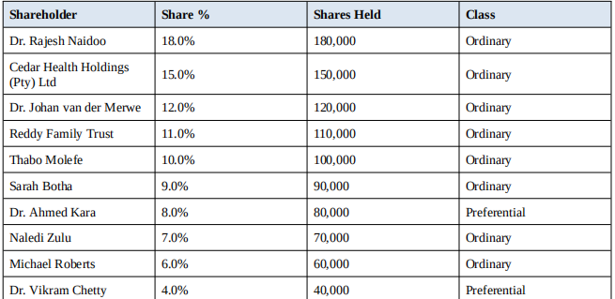
Staff salary
